Example 1
Design a Moore machine to generate 1’s complement of a given binary number.

Solution
According to first complement, if the given input is “1” then the output will be “0” and if the input is “0” then the output will be “1”.
For First complement there should be at least three states.
- One state is start state.
- The 2nd state is to accept “1’s” as input and produces output as “0”.
- The 3rd state will accept “0’s” as input and producing output as “1”.
Hence the final Moore machine of given example 1 will be,

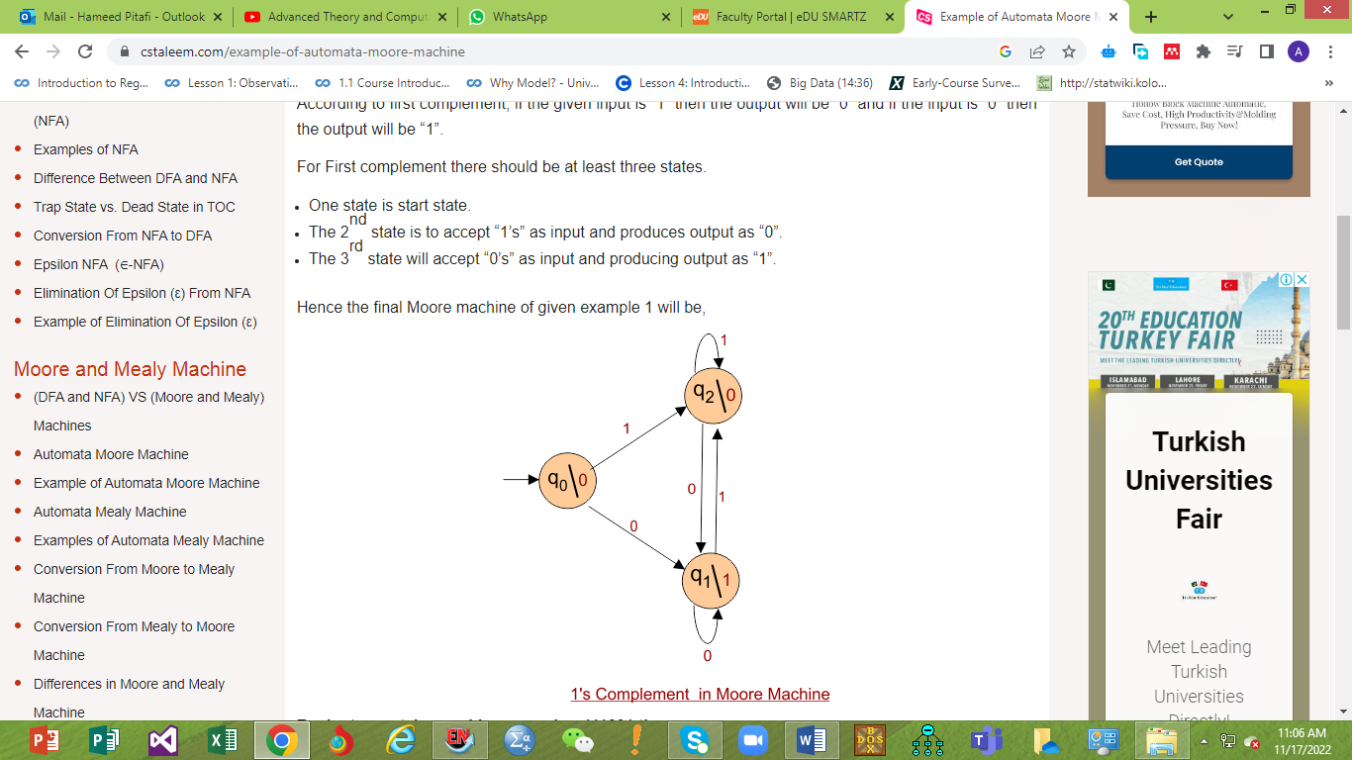
For instance, take one binary number 111001 then

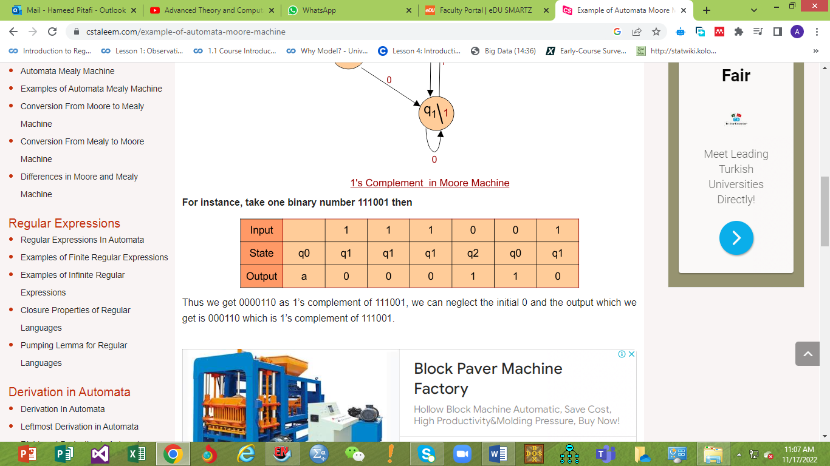
Thus we get 0000110 as 1’s complement of 111001, we can neglect the initial 0 and the output which we get is 000110 which is 1’s complement of 111001.

Example 02

Construct a Automata Moore Machine that prints “a” whenever the sequence “01” is encountered in any input binary string.

Solution
Automata Moore Machine for given example is given below
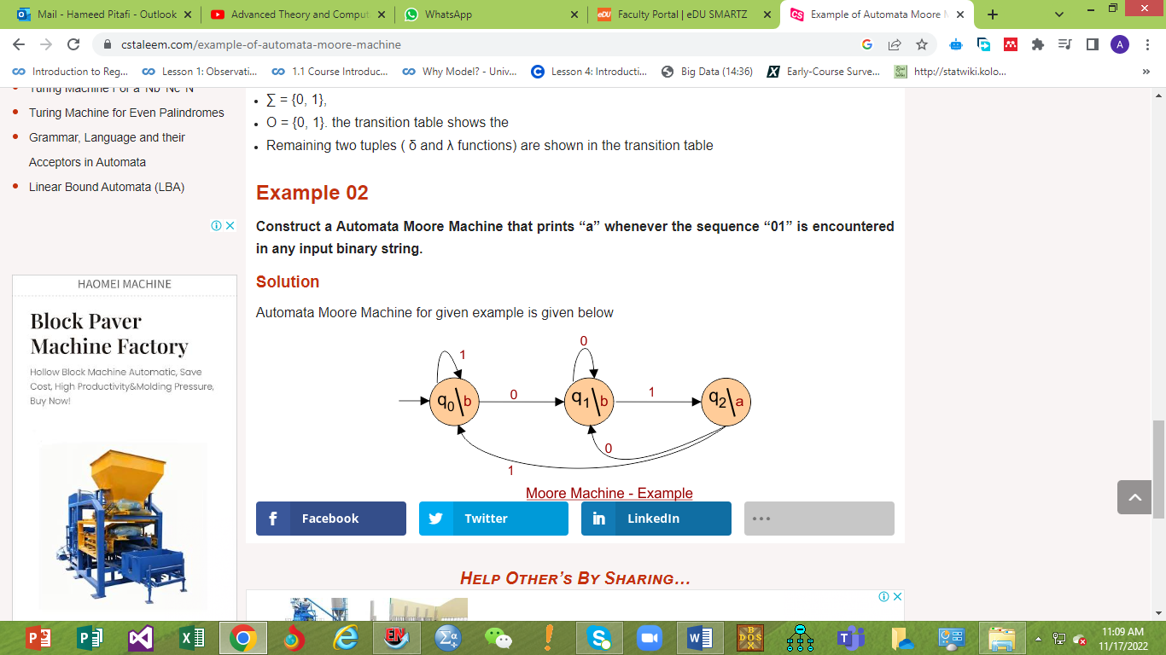
Design a Moore machine for a binary input sequence such that if it has a substring 101, the machine outputs A, if the input has substring 110, it outputs B otherwise it outputs C.

Solution
For designing such a machine, we will check two conditions, and those are 101 and 110. If we get 101, the output will be A, and if we recognize 110, the output will be B. For other strings, the output will be C.
Moore machine has 6 tuples
(Q, q0, Σ, O, δ, λ)
Where,
- Q: Finite set of states
- q0: Initial state of machine
- Σ: Finite set of input symbols
- O: Output alphabet
- δ: Transition function where Q × Σ → Q
- λ: Output function where Q → O
The partial diagram will be as follows −
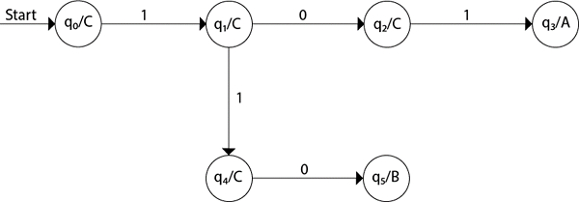

Example 1
Now, we will insert the possibilities of 0's and 1's for each state.
Thus, the Moore machine becomes as follows −
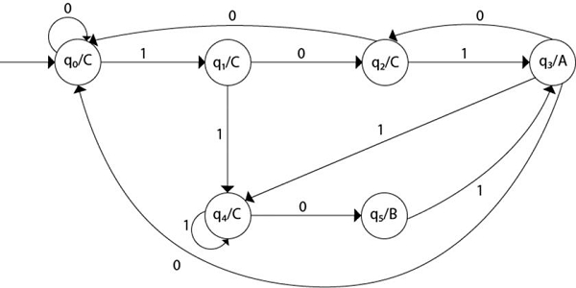

Explanation
- Step 1 − q0 is the start state on input ‘0’ goes to q0 and on ‘1’ goes to q1 generating output C.
- Step 2 − q1 on ‘0’ goes to q2 and on ‘1’ goes to q4 generating output C.
- Step 3 − q2 on ‘0’ goes to q0 and on ‘1’ goes to q3 generating output C.
- Step 4 − q3 on input ‘0’ goes to q2 and to q0 and on ‘1’ goes to q4 generating output A.
- Step 5 − q4 on input ‘0’ goes to q5 and on ‘1’ goes to q4 generating output C.
- Step 6 − q5 on input 1 goes to q3 generating an output B.

Example 2
Construct a Moore machine On input string bababbb, the output is 01100100.
Input alphabet − Σ = {a, b}
Output alphabet − Γ = {0, 1}
States − q0, q1, q2, q3
State Transition table
The transition table is as follows −
Current State | a | b | Output
q0 | q3 | q2 | 0
q1 | q1 | q0 | 0
q2 | q2 | q3 | 1
q3 | q0 | q1 | 0

State Transition diagram
The transition diagram is as follows −
